Major Reese Thompson Grubert, 116th Infantry Regiment The Man behind the Camera is revealed
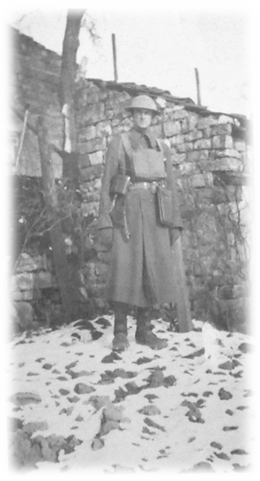
1918-1919

Name/Rank. Major Reese Thompson Grubert, Beverly Manor, VA (Staunton) Churchville Road, Augusta County 10 Feb 1884-1969
Education. TBD. Appears he “Read The Law” vs Degree?
Member: 116th: approximately 1910-1933

Employment. Solider, Lawyer, Civil Engineer, 116th Regimental Historian, Photographer, and Research Analyst

Significant Donations: Major Grubert's Photo Album 1916-1945. Approximately 400 pictures.

See Album 2013.650

Family. Never Married, Lived with his Mother till her passing. The Weller and Ast (later changed to Aust) families were listed as his next of kin (NOK).
Source of Commission: TBD*
Military Assignments: Lieutenant*, 1st Lieutenant, Captain, and Major of Infantry

Awards and Decorations: VA Volunteer (Pre Dates National Guard establishment by law in 1903), Medal (Pre-WWI) 12 years Svc; VANG Svc Medal with 2 Dogwood Blossoms; Mexican Border Svc Medal 1916;WWI Victory Medal 1917-1919 with 2 Overseas Campaign Bars.

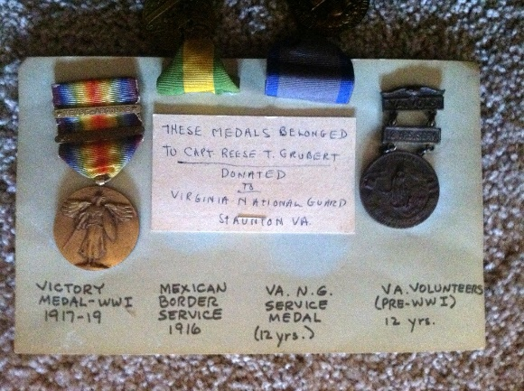

2011.1

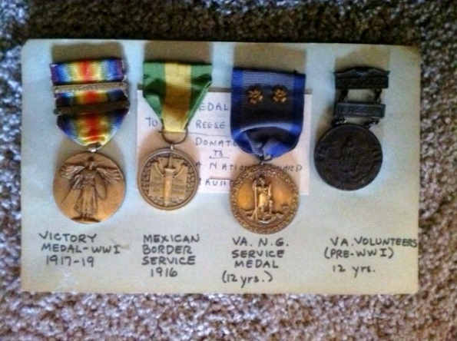

Service Record.

Major Grubert served as 110th MG Bn Supply Officer and later Legal Officer during WWI. The unit returned after occupation duty in German, through Ireland, Scotland, and disembarked in New Jersey to demobilize at Ft. Lee, VA in 1919.

Mexican Border Service.

Major Grubert's Photo Album 1916-1945 is a unique photographic history of the Regiment and his experiences. It captures people, places, and equipment of the 1st, 2nd, 4th Virginia Infantry Regiments. These units, formed the; 1st Virginia Infantry Regiment (Provisional) entering active duty under the command of Gen. John J. Pershing serving on the Mexican Border. They returned to Staunton, VA in 1917. The Regiments were soon alerted and drafted into active service later the same year to serve in World War I.

World War I.

In 1917, the regimental elements of the VA 1st, 2nd, and 4th Regiments of Infantry formed the 116th Infantry Regiment. Upon arrival at Camp McClellan, AL, the 116th became one of three Infantry Regiments in the 29th Infantry Division.
The Div. deployed to France as part of the American Expeditionary Force (AEF). Major, then Capt. Grubert served as 110th MG Battalion Supply Officer and later Summary Court Officer during WWI. The unit returned by ship after occupation duty in German, through Ireland, Scotland, and disembarked in New Jersey to demobilize at Ft. Lee, VA in 1919.

Post World War I. He returned with the Regiment and continued to serve through the 1930s. A 1921 Annual Training Encampment roster list him as the Commander of , Company A, 1st Virginia Infantry Regiment (Provisional) for the Encampment at Camp Meade, MD, Virginia National Guard, 22 July 1921, at Camp Meade, MD. A photograph of him is listed in a Museum Inventory Journal from the 1980s but has not been found to date. Major Gurbert retired from active Virginia Army National Guard service prior to World War II.

World War II

Major Grubert (Retired) registered for the Draft in 1941 at the age of 57. During World War II, he spent time in Hawaii. This is revealed in photographs from Hawaii in the album. The reason for this extended travel and his involvement in WWII for this travel is turns out to be his second profession as a Civil Engineer, employed by the War Department.

Publications.

Grubert, Reese T. "Notes on the Militia Organization of the County of Augusta and Town of Staunton, Virginia - 1742 to 1865." Manuscript, 29 January 1953 with supplement, 15 March 1956. [Copy in the collections of the United States Army Center of Military History] and Library of Virginia
Grubert, Reese T. “Senior Ancestor Regiment 1742-1792”. Reese T. Grubert, Former Major 116th Infantry, Virginia National Guard, Churchville Road, Augusta County September 15, 1956.
Grubert, Reese T. “Line of Senior Ancestor Regiments” Reese T. Grubert, Former Major 116th Infantry, Virginia National Guard, Churchville Road, Augusta County, Jul 1956.
Note. Major Gurbert’s original papers, above and including his Operations Reports during the Danville, VA Mill Strike are in our 116th Regimental archives. 2015.XXX.
Donations to the Regiment

Major Grubert's Photo Album with approximately 400 pictures of the 1st VA Infantry Regiment (Provisional) a.k.a. 116th during the Mexican Border Campaign, World War I, Post War Years to 1945.

Description. 2013.650. This unique photo album captures people, places, and equipment of the 1st, 2nd 4th Infantry Regiments formed into a provisional unit; entering active duty under the command of Gen. John J. Pershing. The unit served on the Mexican Border, returned in 1917, was reactivated as the 116th moved to Camp McClellan, AL, and became one of 3 Infantry Regiments that were formed into the 29th Infantry Division. The Div. before being deployed to France as part of the American Expeditionary Force (AEF). Note. There is a list of all units of the Virginia National Guard Mustered out of Service after the Mexican Border Campaign (the second Mexican War) on file with the Library of Virginia. See attached.

Awards and Decorations. 2011.1 See above information

Major Reese Thompson Gurbert’s and Family History

Reese Thompson Grubert and his twin brother August Alexander (died in early childhood) were born on February 10, 1884, in Staunton, Virginia, their father, Washington, was 24 and their mother, Emma, was 24. He had one brother.
He died on January 2, 1962, in Augusta, Virginia, at the age of 77, and was buried in Staunton, Virginia.

In 1900, Reese T. Grubert was 15 years old and lived in Staunton, Virginia with his father and mother. 1900 United States Federal Census

1908
Reese T. Grubert lived in Staunton, Virginia in 1908. U.S. City Directories, 1821-1989

1910
In 1910, Reese T. Grubert was 26 years old and lived in Staunton, Virginia with his mother. 1910 United States Federal Census

1912
Reese T. Grubert lived in Staunton, Virginia in 1912. U.S. City Directories, 1821-1989

1914
Reese T. Grubert lived in Staunton, Virginia in 1914. U.S. City Directories, 1821-1989

1919
Reese T. Grubert lived in Staunton, Virginia in 1919. U.S. City Directories, 1821-1989

1920
In 1920, Reese T. Grubert was 34 years old and lived in Staunton, Virginia with his mother. 1920 United States Federal Census

1922
Reese T. Grubert lived in Staunton, Virginia in 1922. U.S. City Directories, 1821-1989 1924

1924
Reese T. Gruber lived in Staunton, Virginia in 1924. U.S. City Directories, 1821-1989

1927
Reese T. Grubert lived in Staunton, Virginia in 1927. U.S. City Directories, 1821-1989

1929 U.S. City Directories, 1821-1989

1930
In 1930, Reese T. Guibert was 46 years old and lived in Beverley Manor, Virginia with his mother. 1930 United States Federal Census
1931
Reese T. Grubert lived in Staunton, Virginia in 1931. U.S. City Directories, 1821-1989

1931
Reese T. Grubert lived in Staunton, Virginia in 1931. U.S. City Directories, 1821-1989

1931
R.T. Grubert lived in Staunton, Virginia in 1931. U.S. City Directories, 1821-1989

1934
Reese T. Grubert lived in Staunton, Virginia in 1934. U.S. City Directories, 1821-1989

April 1, 1940
On April 1, 1940, Reese T. Grubert was 56 years old and lived in Beverly Manor, Virginia with his mother. 1940 United States Federal Census December 12, 1940

1942
Reese Thompson Grubert was living in Augusta, Virginia, when he registered for the World War II draft in 1942 at the age of 57.

U.S., World War II Draft Registration Cards, 1942 is on geneorlogy.com

International Travel.

Deployed to and from Europe during World War I.
Reese T. Grubert left San Juan, Puerto Rico, for Philadelphia, Pennsylvania, arriving on December 12, 1940, at the age of 56. Source. Philadelphia Passenger Lists, 1800-1945

The Virginia National Guard in Mexican Border Service 1916-1917
Muster-Out Rolls Below
Infantry Elements of the 1st, 2nd, and 4th Virginia Infantry and Other Units mobilized for Mexican Border Service
On March 9, 1916, Poncho Villa and a band of Mexican bandits raided the town of Columbus, New Mexico, killing seventeen Americans. President Woodrow Wilson ordered Maj. Gen. John J. Pershing and a 15,000 - man force on a "Punitive Expedition" into Mexico. The War Department telegraphed the governor of Virginia to mobilize the Virginia National Guard to protect the Mexican Border while the Regular Army units carried out the expedition. Two regiments of infantry (the 1st and 2nd Regiments), four batteries of artillery, and the signal and field hospital units were sent. In addition, the Richmond Light Infantry Blues, who petitioned the War Department to be included, joined as the 1st Squadron, Cavalry. Later, an engineer company was added to the force of over 3,000 men from Virginia. After a relatively uneventful service, these forces were demobilized in early 1917.
Scope and Content Information
The muster-in rolls provide the following information regarding the soldier: name, rank, age, height, complexion, eye color, hair color, where born, occupation, single or married, residence, emergency notification (includes name, relationship, and address of individual), date of commission or enlistment, home station, signature subscribing to oath, whether they qualified in volunteers, and remarks (usually indicate date enlistment expires).
The muster-in rolls document the musters of the following units of the Virginia National Guard during the Mexican Border Service: recruiting detachment of the 4th Infantry; Quartermaster Corps of the 4th Infantry; Type 0, Field Company, Signal Corps; Field Hospital No.1; Medical Corps; Headquarters 1st Battalion, Field Artillery; Batteries "A" through "0", Field Artillery; Field & Staff of the 1st Squadron of Cavalry; Troops "A" through "0", 1st Squadron of Cavalry; Field, Staff, and Band of the 1st Regiment; Medical Corps attached to the 1st Regiment; Co.'s "Aft through "M", 1st Regiment; Field, Staff, and Band of the 2nd Regiment; Hospital Corps of the 2nd Regiment; Co.'s "A" through "M", 2nd Regiment.
The muster-out rolls provide the following information regarding the soldier: name (present or absent), rank, when enlisted, and remarks (e.g. a.w.o.l., transferred, sick).

The muster-out rolls document the musters of the following units of the Virginia National Guard during the Mexican Border Service:
- Field & Staff of the 1st & 2nd Regiment Infantry;
- Supply Co.
- 1st Virginia Infantry; Headquarters Co.
- 1st Va. Inf.; Machine Gun Co.
- 1st Va. Inf.; Companies "A" through "M", 1st Va. In
- Sanitary Troops,
- 2nd Va. Inf.; Supply Co.
- 2nd Va. Inf.; Machine Gun Co.,
- 2nd Va. Inf.; Companies "A" through "M", 2nd Va. Inf.
- Medical Corps, 2nd Va. Inf.; Detachment of the 4th Va. Inf.
- Co. A. 4th Va. Inf.; Detachment of the 1st Battalion Va. Cavalry;
- Headquarters 1st Battalion Va. Field Artillery;
- Batteries "A" through "D", 1st Battalion Virginia Field Artillery
- 1st Va Field Hospital;
- 1st Signal Company, Co. A;
- Co. A Engineers; and Quartermaster Corps.
2
Source Information: Repository Library of Virginia, Accession number 32116 Title Virginia National Guard, Mexican Border Service Muster Rolls, 1916-1917 Physical Location State Records Collection, Dept. of Military Affairs (Record Group 46)

Photos of Columbus New Mexico just before the Poncho Via Raid
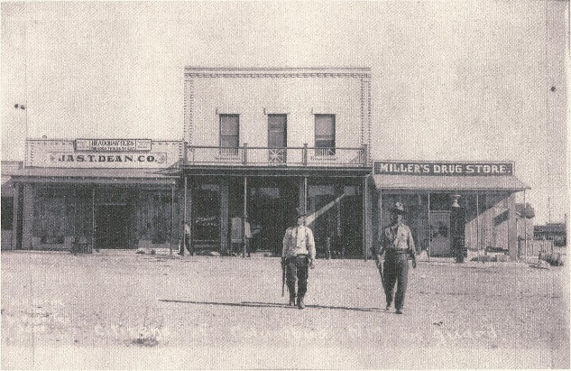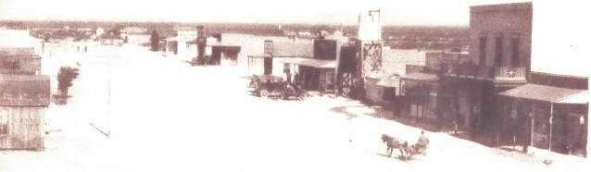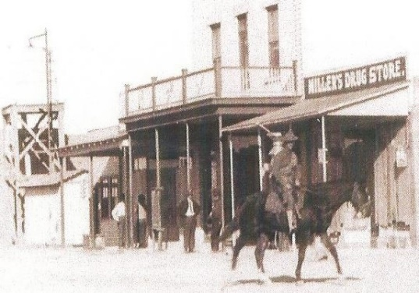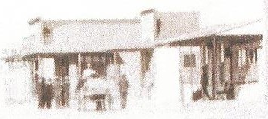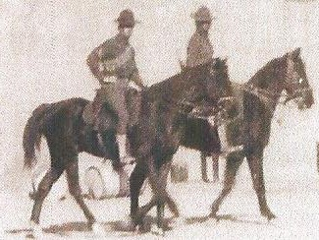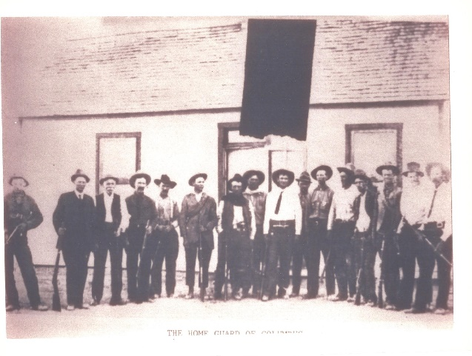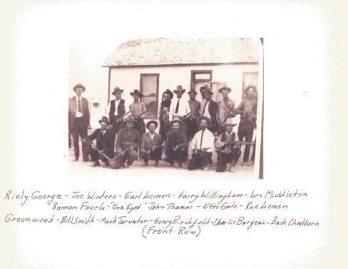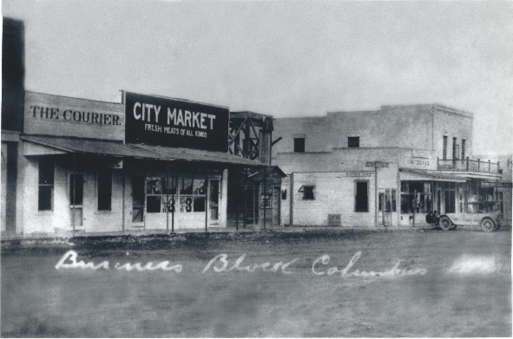These photos are from the Denton Milton Family Collection.

